# Task 1 Report — Customer Retention Enhancement (SmartBank / Lloyds)

## 1. Objective
Prepare and explore customer data to identify features related to churn and produce a cleaned dataset suitable for predictive modelling.

---

## 2. Datasets used & rationale
**Files loaded from the provided package**
- `Customer_Demographics` — demographic information (Age, Gender, MaritalStatus, IncomeLevel).
*Rationale:* demographics often correlate with product preferences and churn risk.
- `Transaction_History` — transaction-level records (TransactionID, TransactionDate, AmountSpent, ProductCategory).
*Rationale:* spending behaviour and recency are strong churn predictors.
- `Online_Activity` — login and service usage (LastLoginDate, LoginFrequency, ServiceUsage).
*Rationale:* product engagement and usage frequency highlight at-risk customers.
- `Churn_Status` — churn flag per CustomerID.
*Rationale:* target variable for predictive model.

> Note: A separate “interactions” dataset (customer support logs) was not included in the files provided; therefore interaction-based features were not created.

---

## 3. Steps performed (code & process summary)
All steps were implemented in `Task1_EDA.ipynb`.

1. **Load & inspect**
- Read all sheets from the Excel file.
- Standardised column names and converted date columns to datetime.

2. **Aggregation & feature engineering**
- Transaction-level features per `CustomerID`:
- `num_transactions`, `total_spent`, `avg_spent`, `last_transaction`
- `days_since_last_transaction` (recency w.r.t. reference date)
- Top product-category counts and `num_unique_categories` (product diversity)
- Online activity features per `CustomerID`:
- `last_login`, `login_frequency`, `service_mode`
- `days_since_last_login`
- Churn target unified as `churn`.

3. **Merging**
- Merged all per-customer aggregations on `CustomerID` to produce a master table.

4. **Cleaning & imputation**
- Counts (`num_transactions`, `num_interactions`, category counts) → missing filled with `0`.
- Numeric fields (`login_frequency`, `total_spent`, `avg_spent`) → missing filled with median (or 0 where domain-appropriate).
- Date-based recency features left `NaN` if no date existed (later filled with median where necessary for modeling).
- `service_mode` one-hot encoded.
- Outliers capped at 1st and 99th percentiles for key numeric fields to reduce skew impact.

5. **Final dataset export**
- Saved cleaned dataset as `cleaned_customer_data.csv` (ready for Task 2 modeling).

---

## 4. Exploratory Data Analysis — Visualisations
All figures are saved and included in the submission.

1. `churn_distribution.png` — bar chart showing target class counts.
2. `total_spent_hist.png` — distribution of total spending per customer.
3. `login_frequency_boxplot.png` — spread and outliers of login frequency.
4. `correlation_matrix.png` — correlation heatmap of numeric features.

**Key EDA findings (high-level)**
- Churn shows class imbalance (please see `churn_distribution.png` for counts).
- Customers with lower `total_spent` and lower `login_frequency` appear to have higher churn rates.
- Recency features (days since last login/transaction) show notable association with churn — more recent engagement correlates with lower churn.
- Product-category diversity and high spending are associated with lower churn risk in aggregate; consider feature interaction analysis in Task 2.

---

## 5. Data cleaning decisions & justification
- **Missing counts -> 0:** Customers with no transactions or interactions logically have 0 counts.
- **Login frequency median imputation:** Preserves central tendency without allowing extreme missing to skew mean-based imputations.
- **Outlier capping (1%/99%)** for monetary and frequency features to prevent undue influence of extreme spenders or erroneous entries.
- **One-hot encoding for `service_mode`:** allows categorical service channel influence to be modelled.

---

## 6. Limitations & next steps
- No explicit customer support interactions dataset was provided — this reduces the ability to capture support-related churn drivers. If available, include it in Task 2 for better performance.
- Consider adding:
- Time-series features (trend of spend across months),
- Feature crosses (e.g., IncomeLevel × avg_spent),
- Aggregated session metrics if session logs are available.
- Next: Build predictive model (logistic regression / XGBoost), apply class balancing (SMOTE or class weights), and evaluate using AUC, precision@k and recall.
## 7. Files included in submission
- `Task1_EDA.ipynb` — notebook with code, outputs and inline commentary
- `cleaned_customer_data.csv` — cleaned dataset for modeling
- `churn_distribution.png`
- `total_spent_hist.png`
- `login_frequency_boxplot.png`
- `correlation_matrix.png`
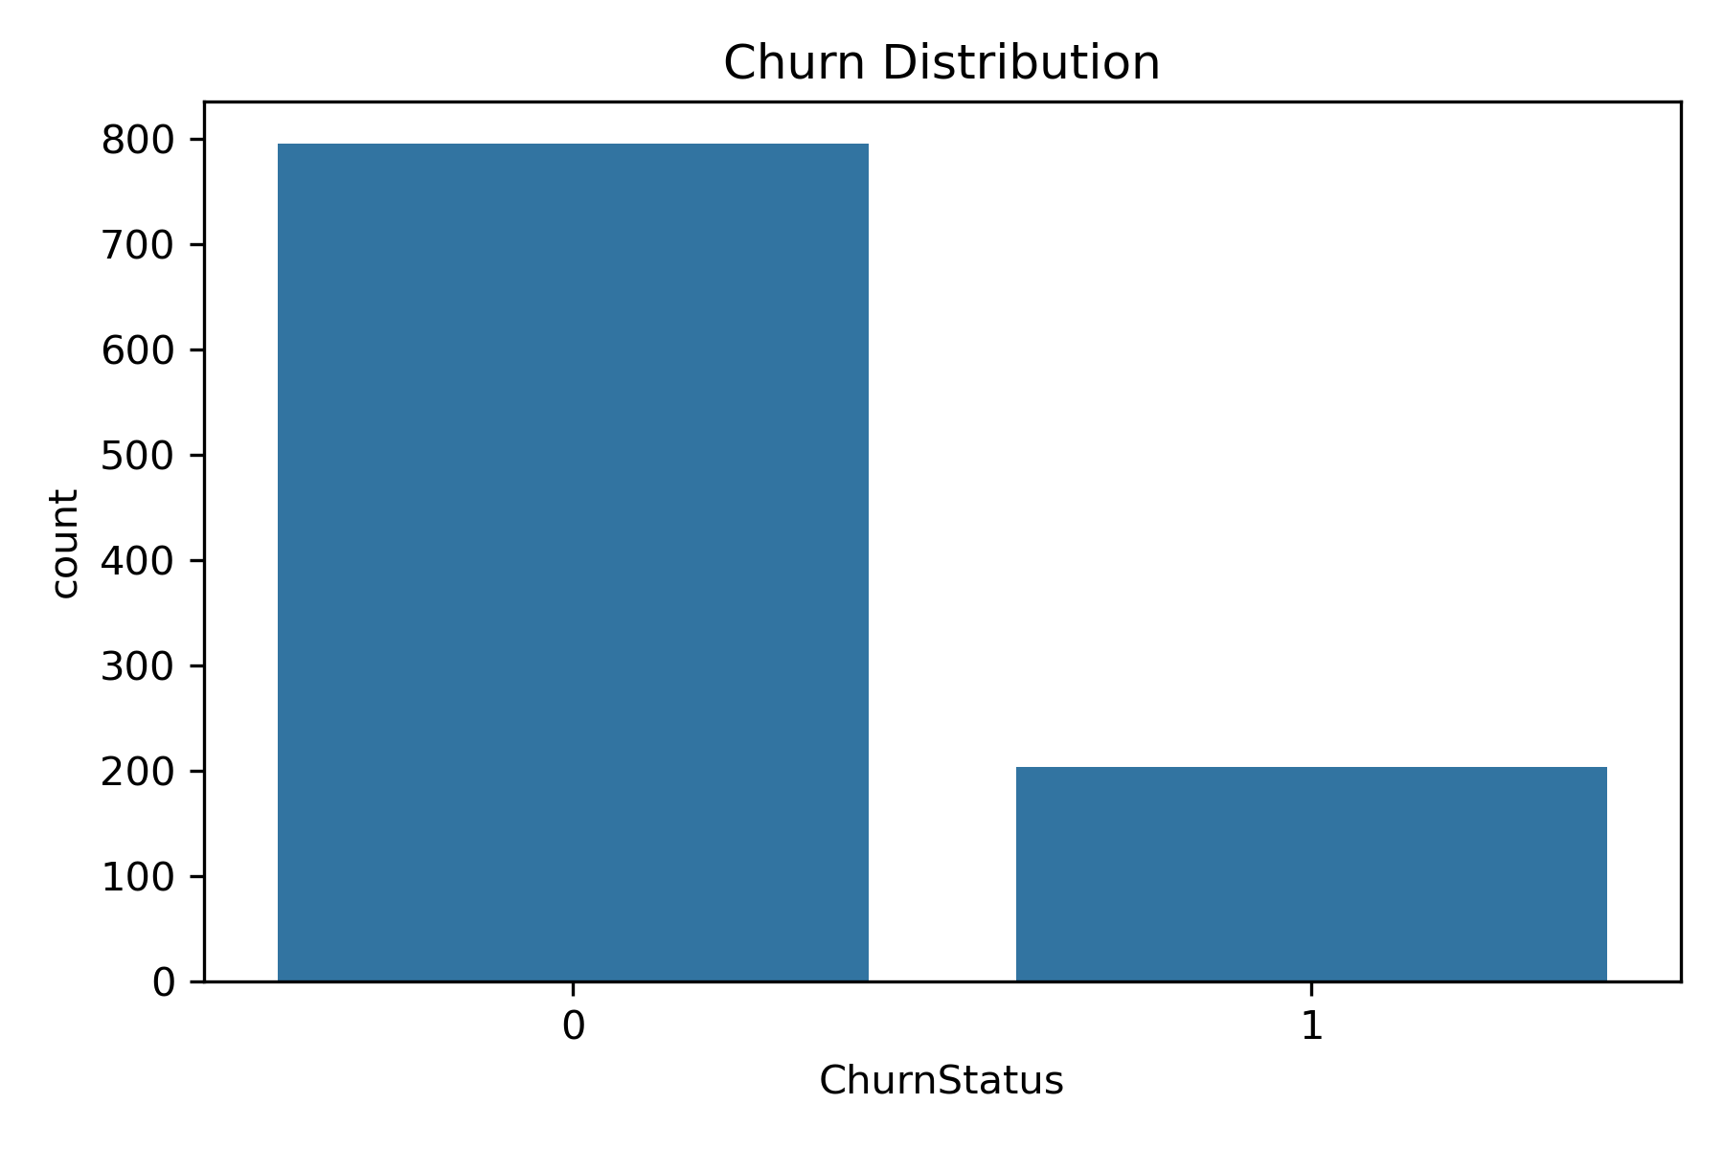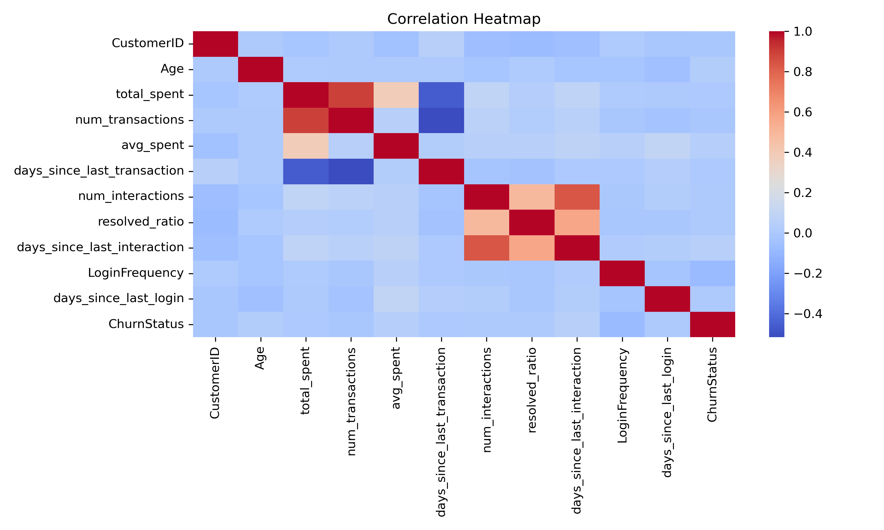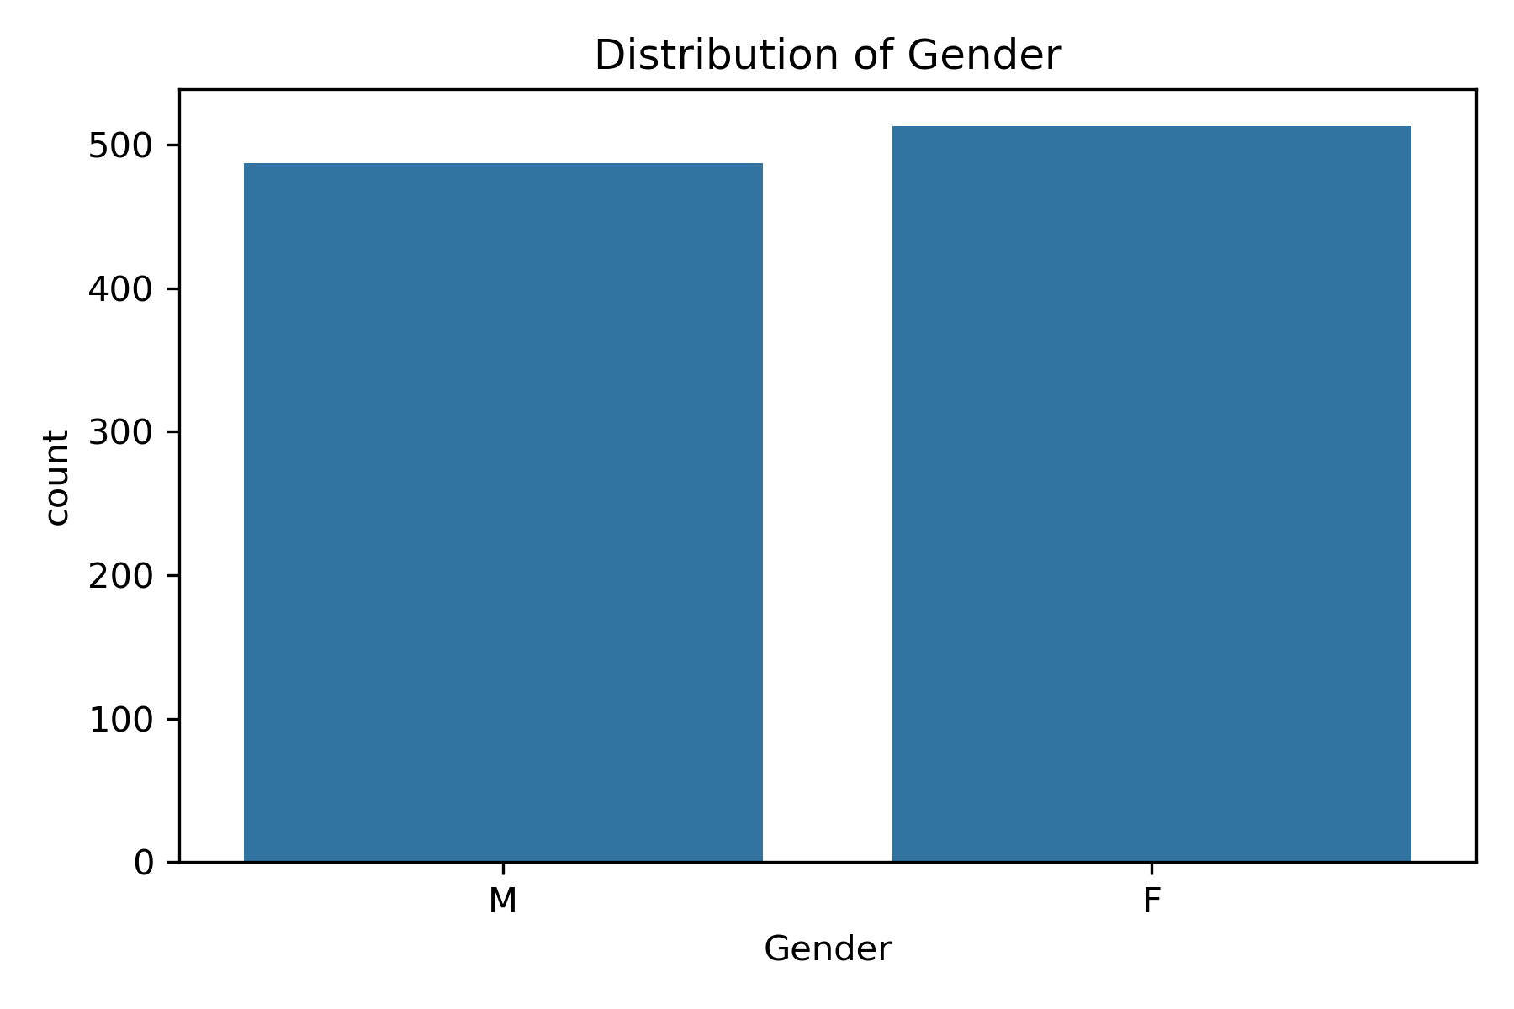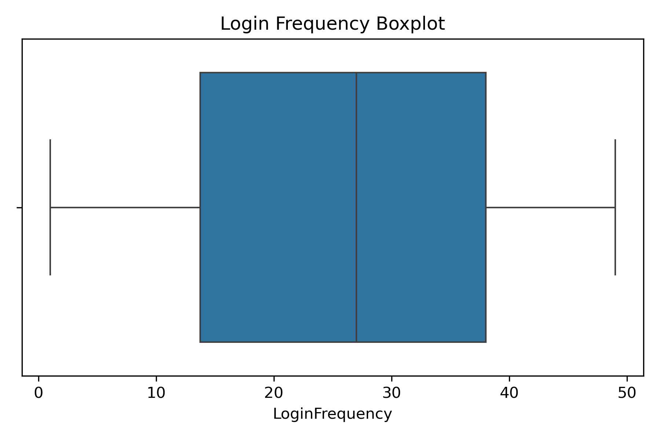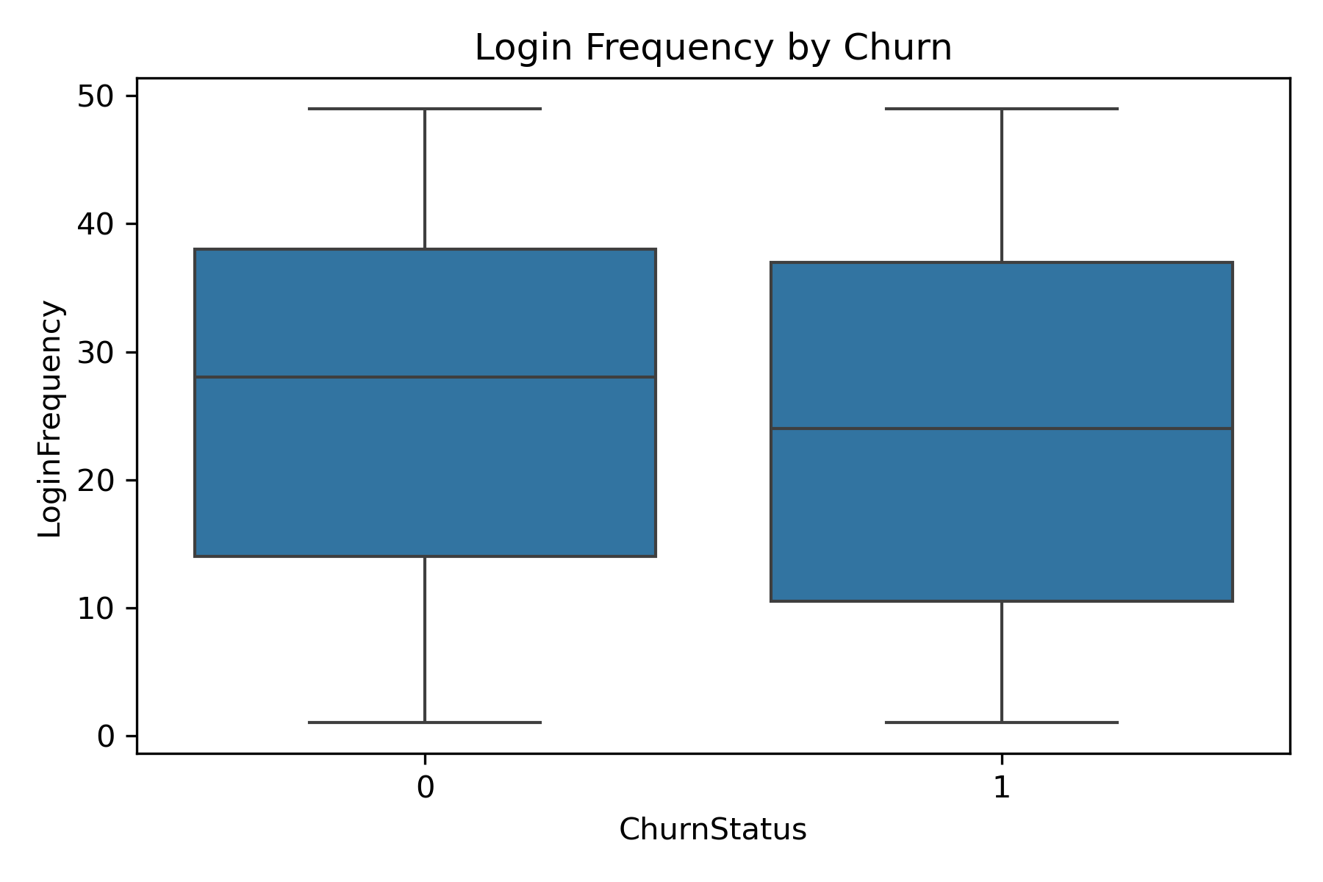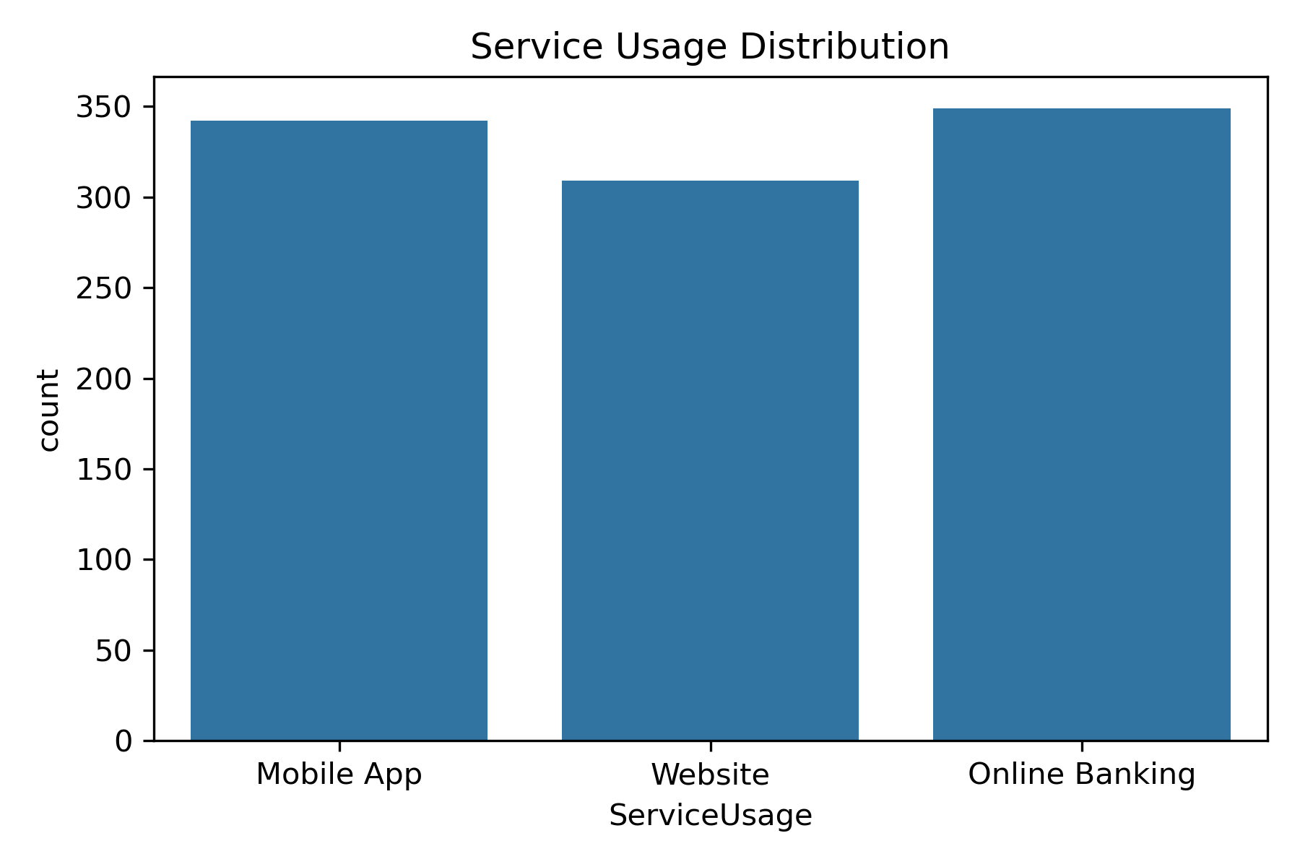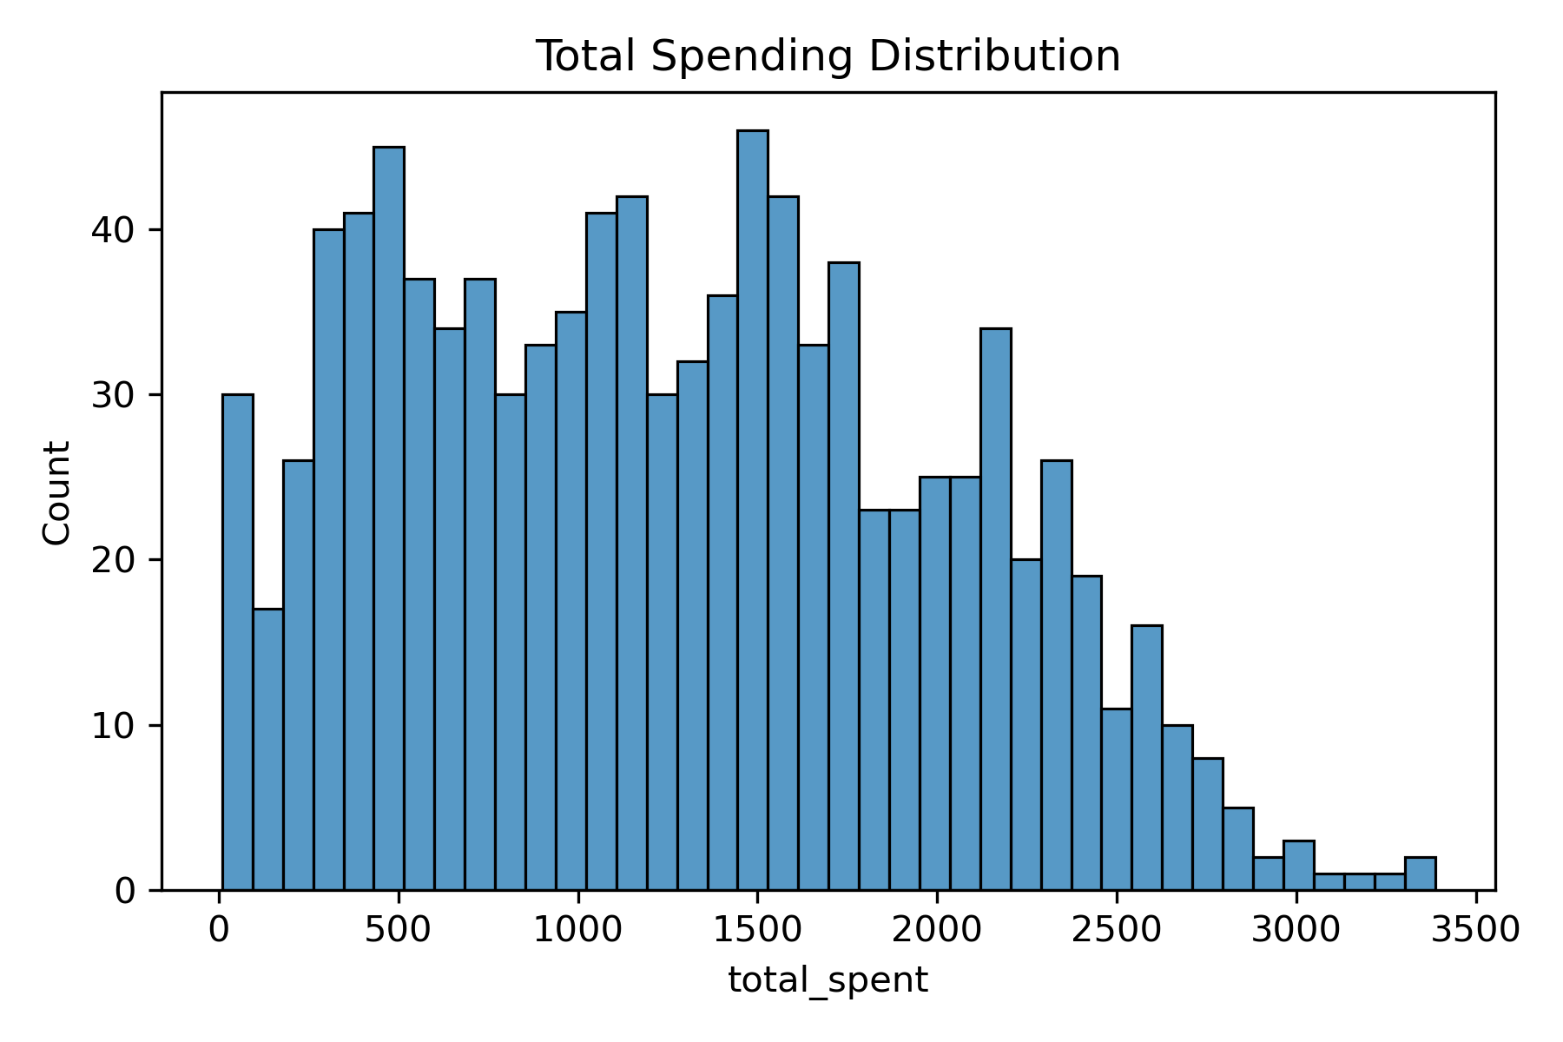
---

## 8. Contact / notes
Prepared by: **Raj Bhirad**
If reviewers want additional EDA slices (e.g., churn by IncomeLevel or churn by ProductCategory), I can provide them quickly.

